|  |  |  |  |
| --- | --- | --- | --- |
| Test Plan Name: | PCT_WF_ DiagnosticList_Cardiology.xls |  |  |
| Solution(s): | PathNet -- BB Transfusio |  |  |
| Created Date: | DD-MM-YYYY | No. Of Steps Requiring Evidence |  |
| Enviroment: | CITRIX | Operating System: | Windows Server 2008 Enterprise Edition |
| Associate ID: | 112 | Domain: |  |
| Test Date: |  |  |  |

Pre-Requisites:

Actual Evidence:

|  |  |  |  |
| --- | --- | --- | --- |
| Step No: | None-1 | Status: | Pass |
| Comments: |  |  |  |

Evidence:

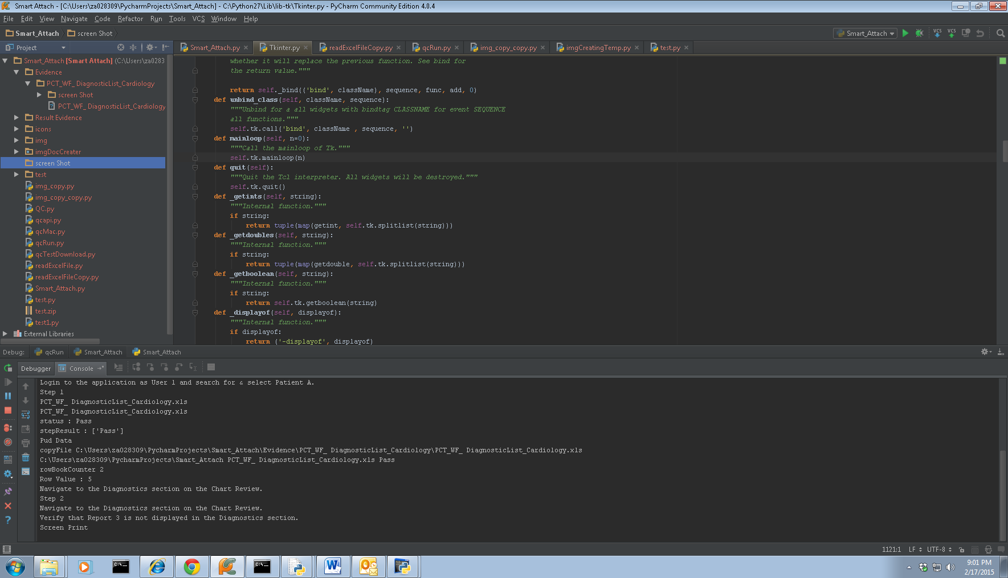

|  |  |  |  |
| --- | --- | --- | --- |
| Step No: | None-2 | Status: | Pass |
| Comments: |  |  |  |

Evidence:

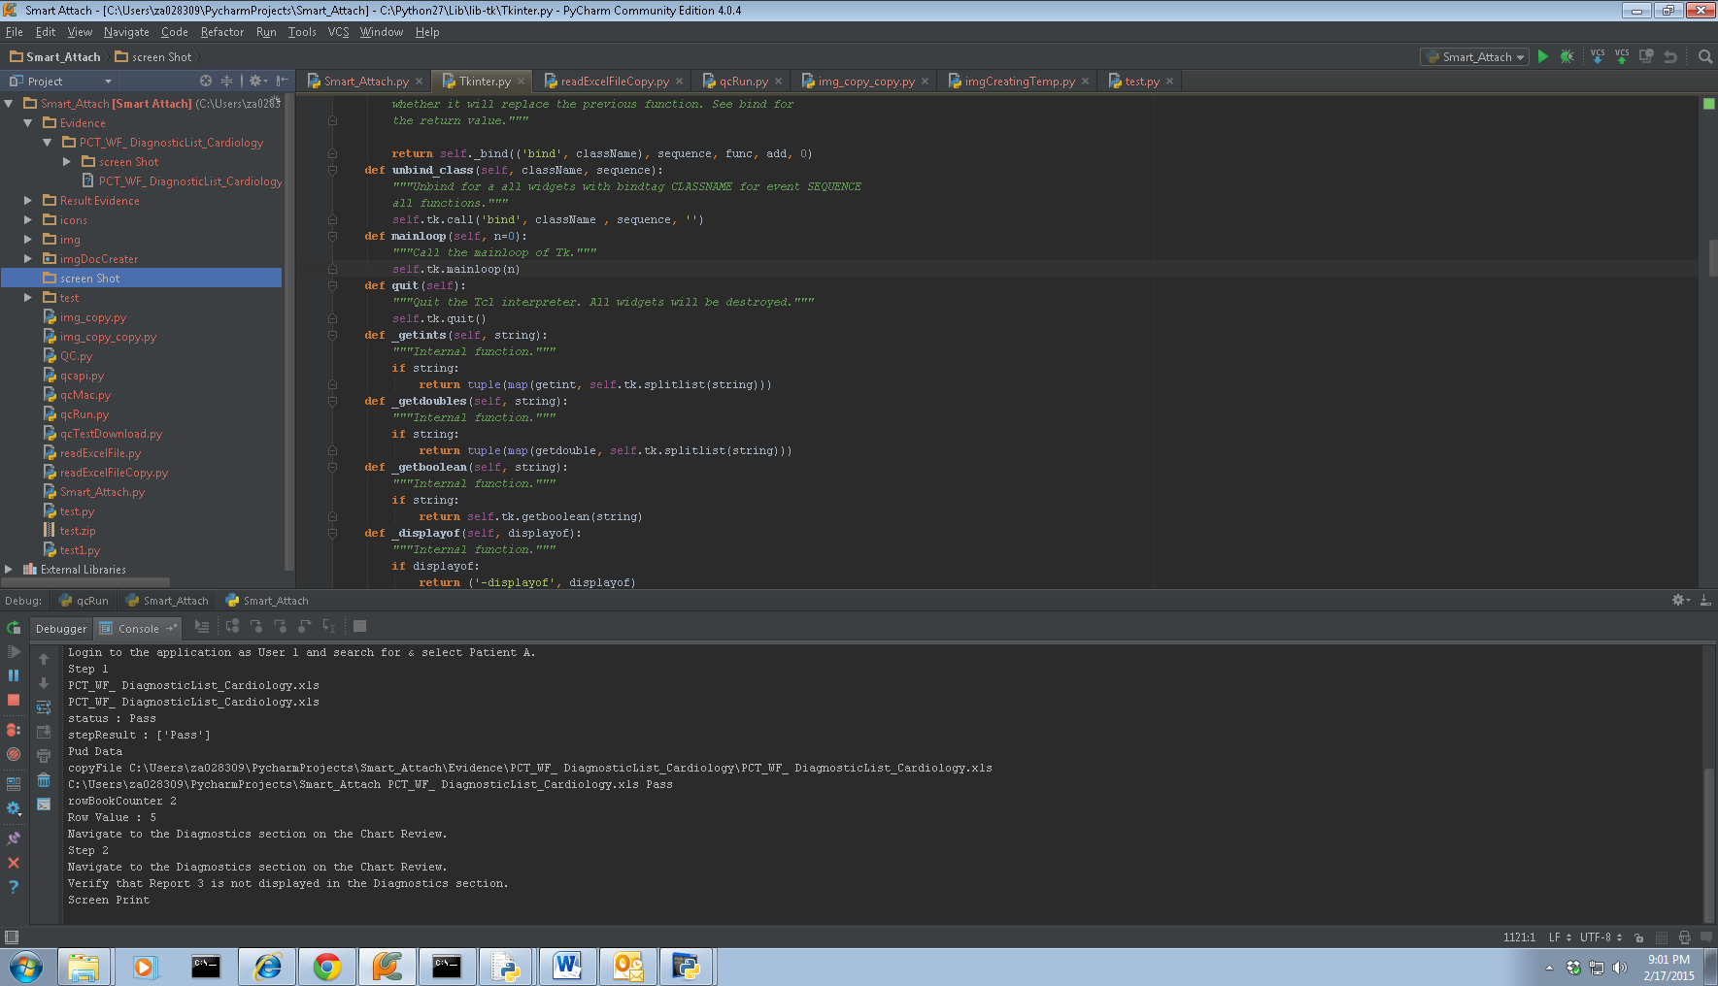

|  |  |  |  |
| --- | --- | --- | --- |
| Step No: | Step 1 | Status: | Pass |
| Comments: |  |  |  |

Evidence:

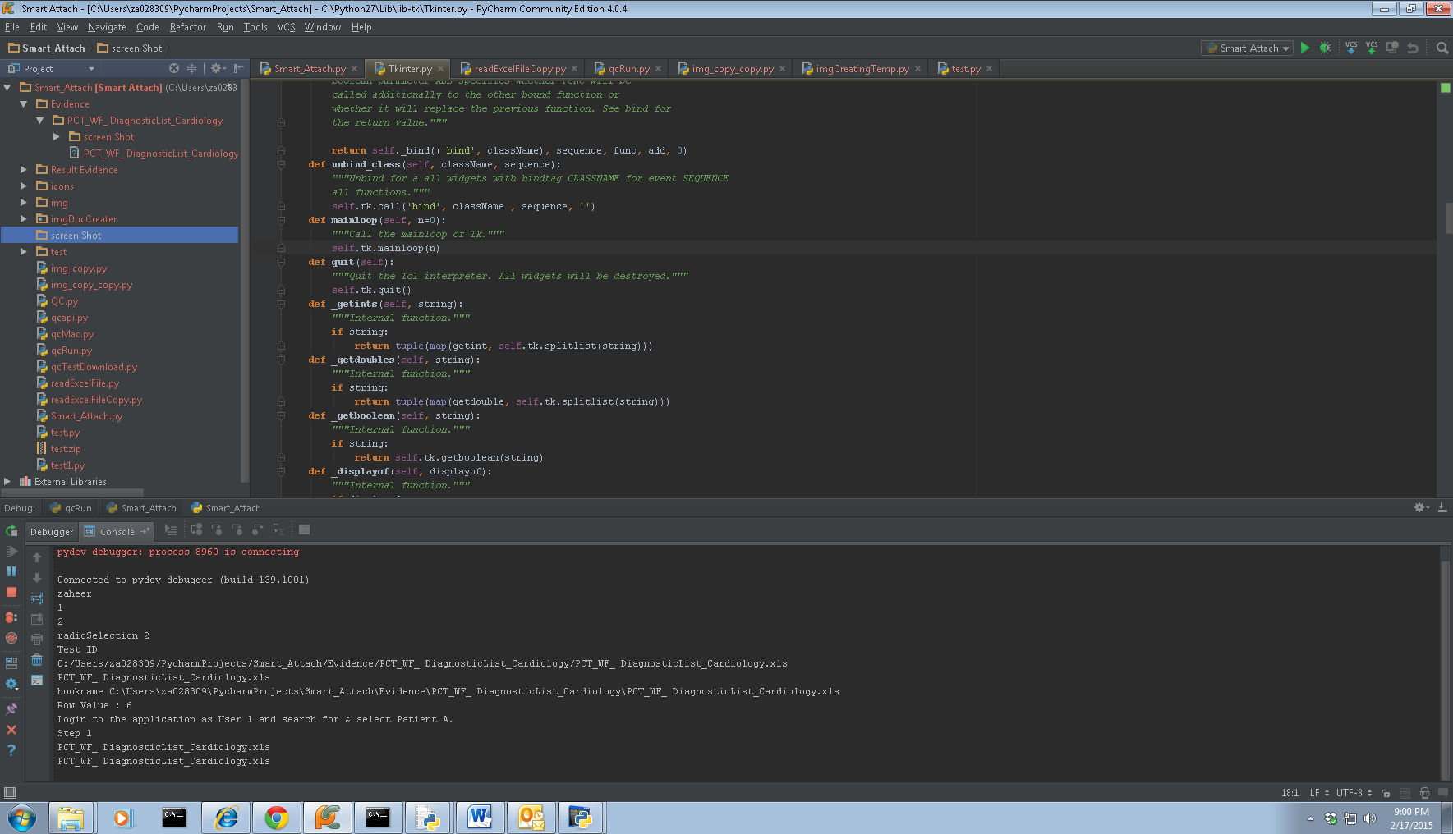

|  |  |  |  |
| --- | --- | --- | --- |
| Step No: | Step 2 | Status: | Pass |
| Comments: |  |  |  |

Evidence:

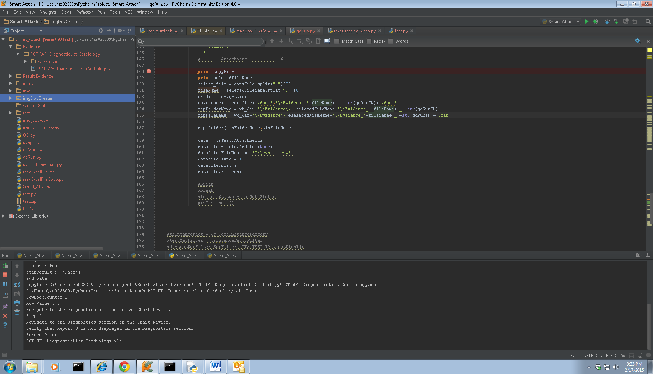

|  |  |  |  |
| --- | --- | --- | --- |
| Step No: | Step 4-1 | Status: | Pass |
| Comments: |  |  |  |

Evidence:

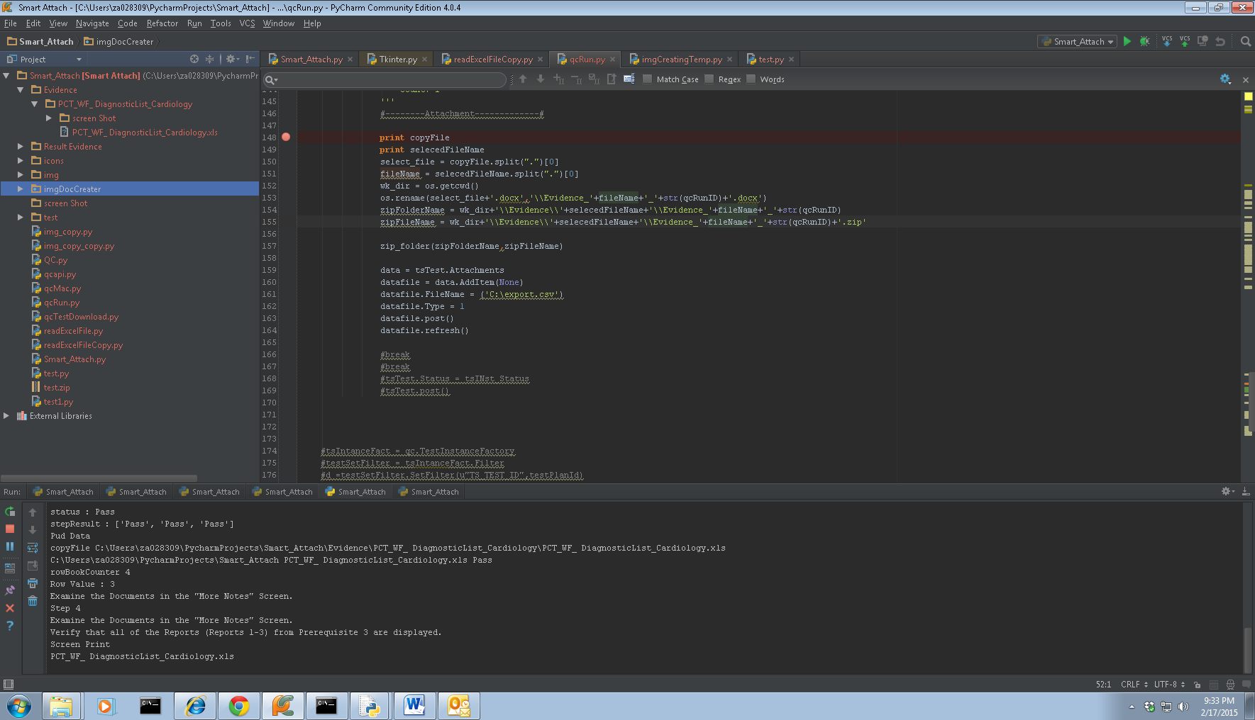

|  |  |  |  |
| --- | --- | --- | --- |
| Step No: | Step 4-2 | Status: | Pass |
| Comments: |  |  |  |

Evidence:

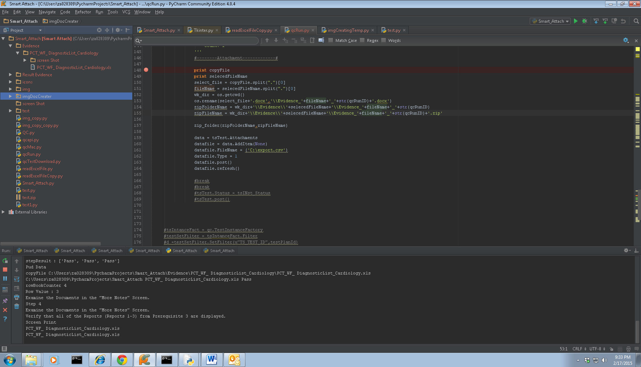

|  |  |  |  |
| --- | --- | --- | --- |
| Step No: | Step 5 | Status: | Pass |
| Comments: |  |  |  |

Evidence:

